**Vplus Basics**

# Commonly Used Terms and Their Meanings

During the course of this document, the following business related terms have been used in several places. The meanings of these terms have been provided here, for easy understanding of the document.

1. Abend: Any unexpected condition encountered while a program is being run. This could be a result of a user/system error.
2. **Bankcards**: These are cards that are issued by any bank or Financial Institution with **MasterCard/Visa as card service providers**. As the name goes, banks alone issue them.
3. **Collateral**: **A security pledged for the repayment of a loan.**
4. **Credit**: **Money available for a consumer to borrow**.
5. **Delinquency**: **Nonpayment of a debt when due**.
6. **Demography**: **A branch of research that studies the characteristics of human populations**
7. **Disposable Income**: **Income (after tax) that is available for saving or**

**Spending**

1. **Economies of Scale**: Reduction in cost of production due to a large number of items produced.
2. **Guarantor**: One who provides a warrant or guarantee for the borrower.
3. **Lien**: **The right to take another's property if an obligation is not discharged**.
4. **Loan to Value Ratio**: The ratio of the loan value given, to the actual value of the asset being secured as collateral.
5. **Mortgage**: A conditional conveyance of property as security for the repayment of a loan.
6. **Origination Fees**: A charge to a borrower (especially for a mortgage loan) to cover the costs of initiating the loan.
7. **Portfolio**: **Collection of different types of financial products**.
8. **Prepayment Penalty**: The penalty required to be paid by the consumer in case he returns the loan earlier than the date agreed upon in the initial agreement.
9. **Private Label Cards**: **Credit, debit or stored value cards that can be used only within a specific merchant's store. Also referred to as proprietary cards.**
10. **Solicitation**: An offer to a customer of a service that a business wants to sell.

Overview of Vision*PLUS*

**Vision*PLUS* is a processing solution** that handles **retail, bankcard and consumer loans/credits all in one system**. This integrated system handles **all types of consumer lending products**.

The key features of Vision*PLUS* are:

* Processes receivables quickly and efficiently.
* **Retains customers through improved customer service and value-added programs**.
* **Processes authorizations more effectively by automating decision making and providing faster, more accurate responses.**
* **Helps track and prevent fraud.**
* **Targets and prioritizes collectable accounts(CTA for collections)**

## *Background*

Vision*PLUS* was introduced in late 1995 by ‘Paysys International’ (Paysys has recently been bought over by a company called ‘First Data Corp’) incorporating the main features of 2 products called ‘CardPac’ and ‘Vision21’.

The first version to be released was Version 2.5. Since then several versions have been released and the latest version to be released is Version 8.14.

## *Technical Details of Vision*PLUS

Vision*PLUS* is available on the following 3 platforms:

* AS 400
* UNIX
* Mainframes
* Language – COBOL (Common Business Oriented Language), JCL (Job Control Language)
* Database – VSAM (Virtual Storage Access Method)
* Front End Interface – CICS (Customer Information Control System)

GE primarily uses **Mainframes** as the platform for its Vision*PLUS* implementations. These mainframes are located at Australia and UK. The mainframe at Australia caters to GE businesses in India (SBI and Countrywide), Japan, Indonesia, Thailand, New Zealand and Australia, while the one in UK caters to GE businesses in UK, Poland, Czech Republic, Hungary and Mexico.

In the U.S., GE uses ‘FDR’ (First Data Resources), a First Data Corp product, for its Consumer Credit business.

# The Industry Vision*PLUS* caters to - Consumer Credit

## *What is Consumer Credit?*

Consumer credit is money lent by a bank, building society, finance company or any other lender to a consumer for personal, domestic or household purposes.

The need for consumer credit arises with the want of products by the consumer, which generally cannot be easily obtained by the disposable income. The consumer hence, needs financial assistance from an institution that can provide it, however at an interest rate that is charged for this service. This can be repaid over a period of time in accordance to terms and condition fixed by the lending institution in consultation with the consumer.

## *Types of Credit*

There are various types of credit instruments that businesses offer consumers depending on the requirements of the respective consumers. The following are the types of credit instruments available and their classification:

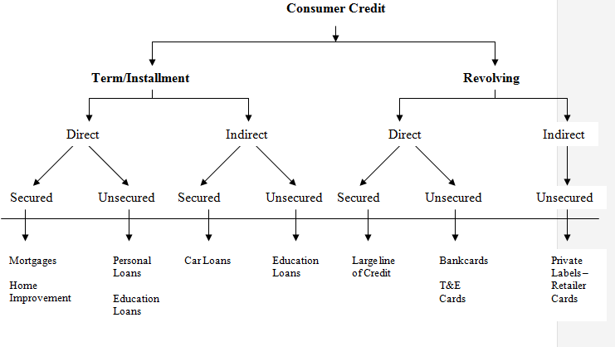

### Term Vs Revolving Loans

**Term or Installment Loan**

A term loan is a product that becomes due at a certain date. The borrower must make the required payment and complete the payment of interest and principal within the pre-determined time period. There are many sub-categories, such as installment payments of interest plus principal, ballooning of principal (i.e. where interest is paid, but principal is not due until the end of the term), and others.

* In a term loan both risk and the profit potential are essentially fixed
* The contractual relationship ends at a definite time (although the business relationship may be re-established later)

**Revolving Credit**

Revolving credit can be open-ended or have an expiration date such as with a credit card. Revolving open-end credit is found with most credit cards. Under agreement with the lender, credit is extended for use by the consumer. An outside limit is established, depending upon the debtor's credit history and ability to handle the debt repayment. The financial institution gives the debtor a credit card

with a credit limit, such as Rs. 50,000, and the debtor can choose how much of the available credit he will use at any given time. Usually the debtor makes periodic (usually monthly) payments, and continues to use the available credit as needed, as long as each periodic payment meets pre-determined minimum amounts.

Revolving open-end credit requires active management by the debtor. The debtor can decide to pay off the entire outstanding debt when the statement is presented, pay off more than the required minimum payment (but not the entire amount), or simply make the minimum required payment. The debtor thus can determine how much credit will be available to him/her at any given time.

For the lender, there is a potential for a long, profitable relationship with the customer, but there are also risks. Events that affect a customer’s ability to pay (divorce, job loss etc.) are impossible to predict. The only source of revenue for these accounts may be a yearly fee and the discount fee from the merchant.

Another card product is the **Travel-and-Entertainment card (T&E)** such as is offered by Diners Club International. This is a convenience product with the charges expected to be paid ***in full each month***. Because the charges are incurred by business people travelling on company account, these tend to be large and clustered. Airline tickets, hotel bills, and car rentals are the most typical uses of the card. Also, they are often incurred overseas or far away from home. Consequently it is possible to run up a large bill in a short time. Tight front-end screening and aggressive fraud controls are used to keep these losses predictable.

### Direct Vs Indirect Loans

###### **Direct Loans**

Loans that are booked directly via branch-based marketing, mail solicitation or even walk-in applications, e.g., Education Loans, Personal Loans, Credit Cards.

###### **Indirect Loans**

Loans that are acquired indirectly through brokers, dealers or retailers, e.g., Car Loans obtained from Dealers.

### Secured Vs Unsecured Loans

###### **Secured Loans**

Loans that are guaranteed or have substantial assets that can be used to satisfy a legal judgment, e.g., Mortgages.

**Unsecured loans**

Loans that are not backed by collateral/assets as security for the credit taken, e.g., Credit Cards

### Recourse Vs Non Recourse Lending

###### **Recourse Lending**

The lender can charge back loan losses to the merchant or dealer in part or in whole. This is applicable only in some kinds of indirect lending.

**Non Recourse Lending**

The lender has to bear the entire loss in case of a payment default by the customer. The merchant/dealer is not liable for any non payment by the customer.

### Card Driven Vs Check Driven Credit

###### **Card Driven Credit**

Card Driven Products as the name goes include bank credit cards and T&E cards. It involves a whole range of point-of-sale authorization issues that affect losses. This is more likely to be used for impulsive purchases in cases where the consumer does not have liquid cash available.

###### **Check Driven Credit**

Relates to the checking account of the customer. The two basic types are:

* Overdraft feature on the checking account
* A separate line of credit activated by the customer drawing a check on his credit account. The separate line is more likely to be used for planned purchases or major expenditures.

### ‘Cards’ Classification

Cards or ‘Plastic Products’ are also commonly classified in the following 3 categories.

* ***Pay Later***: Periodical Statement is sent to the cardholder, indicating all card activity since the previous statement. Terms of payment depend on the set up selected by the issuer, e.g., Credit Cards, T&E Cards.
* ***Pay Now***: Cardholder’s account is debited shortly after the transaction takes place, e.g., Debit Cards.
* ***Pre-Paid:*** Cardholder’s account is debited before use, e.g., Petro Cards, Phone Cards.

Pay Now and Pre-Paid cards are **not** credit products since there is no loan being extended to the customer.

### Various phases in the Consumer Credit process flow

**Every organization that deals in consumer credit invariably follows a process flow** in introducing and maintaining a product in the market. There are five major phases in any credit product lifecycle, viz., Product Planning, Credit Initiation, Account Maintenance, Collections and Write Offs.

**Product Planning**: This phase involves studying the target market and local conditions and deciding on the type of the product and the terms and conditions under which it will be offered to consumers.

**Credit Initiation**: This involves designing the application forms which will be used to screen consumers, and processing the filled-in forms received from the consumers. Decisions regarding which customers to accept/reject and the credit limit to be extended to individual consumers is taken in this phase.

**Account Maintenance**: This is the phase where the customer makes transactions using his credit product and activities like transaction authorization, transaction posting, billing and payment handling are undertaken. This is also the phase where the organization tries to maximize its relationship with the customer in terms of the additional products offered.

**Collections**: When a customer fails to make a payment, the account details are handed to the collections division to follow up with the customers for the outstanding balance. Collectors use different methods to contact customers depending on the amount and extent of delinquency.

**Write-Offs:** When a delinquent account can no longer be collected, due to reasons like non-payment by customer despite all efforts, death of the customer etc, the account is closed and the outstanding amount is written off as bad debts.

**MIS and Risk Management**

A Management Information System (MIS) enables the organization to make strategic decisions in each of these stages with regard to any of its credit products.

A sophisticated MIS aggregates up to date information of potential and existing customers and maintains a dynamic database that captures customer critical information for the organization. It thereby enables the organization in strengthening its ***risk management*** capabilities. Being an integral part of the credit product lifecycle it serves as a support system to various corporate departments helping them take critical decisions as accurately as possible.

With the help of an MIS the organization is therefore in a position to:

* Assess the risk involved in adopting the approach in introducing the product to the market
* Determine the “odds of repayment” of a customer, thereby allowing the organization to gauge the level of risk associated with a particular customer on an ongoing basis.

The following diagram depicts the typical inter-relationships between these phases.

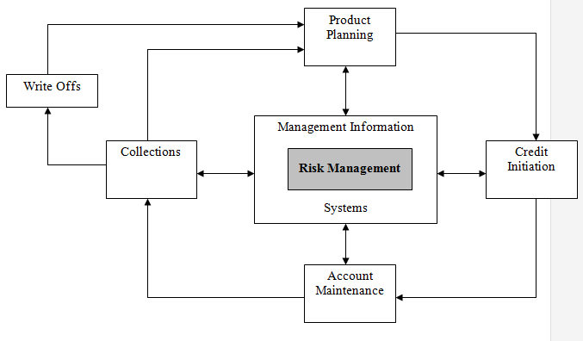

### Product Planning

The first step for any Consumer Credit business is to decide what products will be offered to the customers, evaluate the profit dynamics of each product and establish the terms and conditions under which these products will be offered. High-volume consumer credit requires detailed planning. There are 6 major Stages in Product Planning:

#### Stage 1: Planning the Consumer Credit Product

The two steps involved in the planning process are assessing the competitive environment and selecting the target market.

***Step 1: Competitive, legal and risk environment analysis:*** This involves studying the competition and their product strategies, understanding the legal requirements of the country, and analyzing the local conditions for certain specific factors that will help plan better.

***Step 2: Target Market:*** Any good credit product plan aims at a target market that contains 1) good credit customers 2) who will use the products and 3) where the business can be profitable. A detailed definition of a target market includes information like Area of Sales for the product, type/profile of customers being targeted, other products that can sold to the target customers, and legal restrictions applicable.

#### Stage 2: Product Selection

There are different types of credit products that can be offered to consumers. The type of product selected by the business to offer to its consumers, will depend to a large extent on the target market and the local conditions. For example, if research indicates that there are many players in the Credit Card segment, but inadequate number of Car Loan players, the business may decide to enter this segment.

#### Stage 3: Standards Product Terms and Conditions

For every approved credit product, there is a “Summary of Terms” describing the standard terms and conditions under which business will be done for that product. A typical plan sheet includes the following data:

***Customer Relationship***

- **Pricing basis - Prepayment penalty - Credit approval process**

**- Life/term of the account - Late charges - Insurance requirements**

**- Maximum/minimum loan - Origination fees - Basis for refunds**

**- Terms of repayment - Guarantees**

***Collateral (Secured only)***

**- Eligible collateral - Loan to Value ratios - Appraisal process**

***Dealer (indirect only)***

**- Eligible dealers - Recourse arrangement - Commissions**

**Repayment Terms**

Repayment terms are terms that specify the amount and the periodicity at which the loans have to be repaid by the consumer to the lender.

**Minimum Payment**

This is the minimum amount that the consumer needs to make every month on his total credit outstanding in order to keep the account active.

#### Stage 4: Profitability Planning

This is the most important step in planning a new product and involves forecasting the revenues, costs, and profit of ***every*** product over its lifetime along with the overall portfolio analysis. The profitability planning reflects the funding strategy, delinquency, write off levels, and process costs that are anticipated in the delivery of the product.

#### Stage 5: Testing, Sampling and Experimentation

Like any other industry, every credit product needs to be tested before it can be launched into the market. A product test resembles the actual product in all ways. Unlike consumer goods, where test marketing is done in a specific area, credit products are test-marketed broadly in the area that will ultimately be the market. The only difference between test and actual product is the scale of the marketing effort.

#### Stage 6: Periodic Reviews

The final step in the planning process is a regular review mechanism for the individual credit products. Each consumer product program has been approved by an individual(s) on the basis of a series of assumptions. Over time the original conditions change. Hence businesses review eachproduct, periodically. A review heightens the sensitivity of the organization to the risk/reward relationship of each product. This review generally includes an up to date description of the product terms, market-share data, volume and direction of growth, purchase quality indicators, key risks and, a current product profitability model.

Having completed the Product Planning phase in the credit product lifecycle, the business organization now has a thorough understanding of the credit product that needs to be marketed and the segment it needs to cater to.

### Credit Initiation

This is the phase where the actual decision of extending credit to individual consumers is made. Who should be offered the credit product, what is the credit that can be extended to individual consumers etc., are some of the decisions that are made in this phase.

#### Evaluation of a Loan Application

The first decision in the credit initiation process is to determine the method and degree of credit evaluation necessary for each application. Each product has an inherent degree of risk and thus requires a degree of credit evaluation appropriate to the risk involved. The degree of investigation ranges from minimal to detailed. For instance:

* *Retailers’ private label cards* typically carry small average balances. The lender typically cannot afford to do more than obtain a completed application from customer, credit score* the application and sometimes obtain a credit bureau* report.
* *Bank credit cards and Travel & Entertainment (T&E) cards* require a thorough customer investigation because of higher potential liability and fraudulent use of these cards, which can be used to make large purchases in locations around the world.
* *Mortgage applications* require the most thorough investigation of the customer and the collateral.

#### Steps in the Credit Initiation Process

The following diagram depicts the steps that are involved in the credit initiation process.

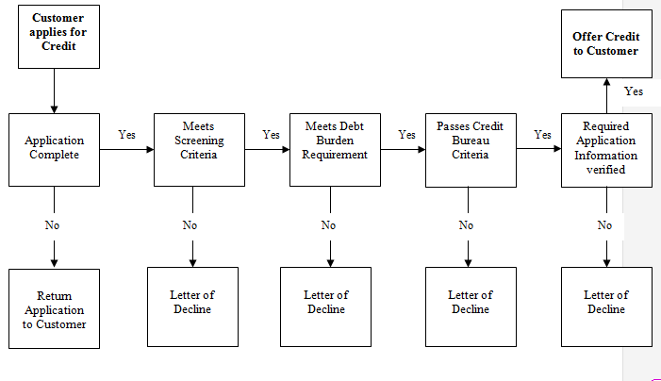

***Step 1: Application Form***

The credit initiation process begins with a well-designed *application form*. The design of the form involves cooperation among several corporate departments like Marketing, Legal, Risk Management, etc.

Any good credit application has the following major categories of information:

* Type and amount of loan;
* Personal background (e.g., name, address, date of birth etc)
* Employment data (e.g., organization, term of employment, annual income);
* Credit information (e.g., creditors, balances, home ownership);
* Financial references(e.g., banks and brokers);
* Credit agreement;
* Data on assets and the collateral (for secured loans only)

###### **Step 2: Screening Systems**

One of the most important decisions in the consumer loan business is to decide on the appropriate **screening system** to be used in acquiring loans for the portfolio.

**Judgmental Screening**

This method involves the loan officer using his/her judgment or experience to make decisions on whom to extend credit to and for what amount. Purely judgmental decisions are subject to biases, both emotional and intellectual. Judgmental lending is impracticable in the high-volume consumer loan environment.

**Credit Scoring / Application Scoring Screen**

Credit scoring involves using a statistical tool to determine the probability of a loan applicant becoming a “good-paying account.” The system consists of a formula-based procedure for evaluating each credit application using numerical values assigned to a set of characteristics that experience has shown tobe relevant in predicting repayment. For instance characteristics like monthly income, title to the house, place of work, designation etc. are generally given high weights to calculate an individual’s credit score.

A ***cut off score*** is then decided depending on the Risk-Volume balance that the business wants to work with. Thus each application, once scored, can be granted or denied in a logical, objective, consistent and efficient manner (based on whether or not it is above the cut-off score).

**Credit Bureau Screen**

The next step is to check the prior credit record of the customer. A Credit Bureau basically operates as a library of the credit history of individual consumers. Individual lending organizations subscribe to bureaus and transmit data from their files to the bureau and the bureau maintains this data. When an organization requests a credit report from a bureau, it receives all of the information in file. This step is generally applicable only for the developed countries.

**Debt Burden Screen**

The process of analyzing a customer’s ability to repay a loan falls under “debt burden” analysis. There are a number of simple formulas that can be used to forecast an applicant’s abilityto repay. Some of the methods are a) use of a Minimum Income Cutoff to give credit, b) analyzing the Total Current Debt to Income Ratio of the applicant, c) Analyzing the Monthly Debt Payments vs., the customer’s Disposable Income.

***Step 3: Customer Verification***

One of the final steps in the credit initiation process is the verification of personal information submitted by the customer.

* Is credit being extended to the applicant and not to a fictitious character?
* Does the applicant work where he or she says?
* Does the applicant earn what he or she says?

***Step 4: Collateral Verification***

Where secured lending is involved, the final and most important step before booking the loan is verifying and appraising the collateral. The process involves two steps: to check the existence of the collateral and to check the appraised value of that collateral.

### Account Maintenance

The term “account maintenance” is the ongoing part of the credit cycle that begins when the account is booked and endswhen the account is either paid in full or becomes more than mildly delinquent. For a business, the purpose of this phase is to anticipate the customer’s financial needs and deepen the relationship with more profitable accounts, and at the same time trim back on those accounts that do not yield an adequate return.

The major Maintenance activities that are required as a part of this phase are:

#### Documentation Maintenance

The original information with which an account is opened usually consists of an application or coupon, plus supporting documentation such as a credit bureau report. All this information must be stored and remain retrievable for use by several functional areas:

* ***Collections*** may need the information to locate a customer.
* ***Marketing*** may find the information useful to better understand the type of individual and the types of financial services that would appeal to him or her.
* ***Legal:*** Credit legislation in several countries requires a business to maintain certain information on all people who apply for credit.
* ***Credit Policy*** may want to use responses to develop or modify scoring systems.

#### Customer Service Systems Maintenance

The sheer volume of millions of account statements, inquiries, changes of address and other account changes make customer service an important cost item. Every lending institution has an enormous stake in billing and recording payments accurately.

For example, just one inaccurate payment posting to an account may generate two or more phone calls, two or more letters of apology and an inaccurate MIS reading. Imagine the problems that will result from mis-posting charges or failing to bill charges on thousands of accounts.

The Account Maintenance phase also involves several **decisions** that need to be made regarding the credit account. The decisions that must be made in this phase include:

1. **Contractual Decisions**

**Judgmental**

This typically involves the lending officer considering each application individually and taking decisions such as renewals or credit limit increases. These one-by-one reviews are expensive and time-consuming, especially when the volumes of applications to be processed run into thousands.

**Behavioral Scoring**

Behavioral Scoring systems basically draw on thousands of actual account histories, using the patterns of account usage and repayment to develop a statistical model for predicting future account behavior. This model can be used to segregate a credit portfolio into “good risks” (those card members whose accounts should be renewed, given credit limit increases, or otherwise retained) and “bad risks” (those accounts whose lines should be capped or eventually terminated),

This is a very powerful tool and is being increasingly used by businesses to make decisions regarding the renewal/termination of current accounts and also serves as an input for other departments.

1. **Marketing Decisions**

Once the business establishes a large statistically screened customer base, the marketing department will work to enlarge and refine the population group with several approaches:

* ***Automatic credit line increases*** for profitable accounts;
* ***Credit Line cancellations*** or ***decreases*** for unprofitable or high-risk accounts; and
* ***Activation*** programs for never-active or rarely used accounts.

1. **Authorization and Fraud Control Decisions**

Another key control point in account maintenance is the decision to authorize, reject or modify a credit charge at the time a customer presents his card to a merchant for a purchase. For example, a merchant authorization can:

* Prevent or limit further credit extension;
* Prevent use of lost or stolen credit cards;
* Provide an opportunity to confiscate cards being used fraudulently;
* Detect patterns of card usage that suggest fraudulent use of a card not yet reported as lost or stolen; and
* Determine that an individual authorized to do so is in fact making a charge.

**Fraud Detection**

There are a few factors that help catch the most obvious fraud attempts:

***Location of Purchase:***

A large purchase at a high-risk retail store represents a different kind of exposure for a creditor than does the charge of an airline ticket by a customer. Also, certain stores quickly acquire a reputation for submitting an excessive number of fraudulent charges.

***Number of recent charges:***

A stolen card is typically used to make a string of purchases before the theft can be reported. A large number of charges within one or two days, triggers review and intervention by the business.

### Collections

Every well-run consumer credit business has a professional collections organization as a key part in the credit process. The fact is that certain customers will always take on debt without any adequate regard for the consequences of that debt. It is the role of a collections organization to remind the customer of the seriousness of his/her contractual relationship with the creditor. The major elements of a collections function are:

#### Account Decision

The decision to put an account into collection is significant for both the customer and the business organization. Once a customer receives a collection call, his or her account remains in collection until it is either brought current or the collateral is repossessed. As long as the account is in collection, the business needs to devote resources to managing it.

Creditors can use any number of different strategies to cope with early delinquencies, such as a) Do nothing, b) Use a message reminder on the customer’s statement, c) Send a personal letter, or d) Make a phone call.

Most businesses follow ***judgmental processes*** (e.g., All accounts one day past due get a statement message; all accounts 15 days past due get a system-generated notice; and so on.) with particular accounts assigned to a collector. Each collector then deals with the account based on the procedures for the age, balance, behavior score, etc of the account.

However, ***Behavioral Scoring***provides the most accurate and sophisticated way to deal with the account. The system can accurately predict the odds of mildly delinquent accounts returning to a non-delinquent state without any collections action and can save the creditor a lot of money in postage alone by eliminating early mail notices.

#### The Collections Process

The following are broadly, the main steps involved in the collections process.

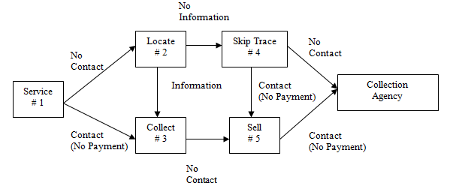

***Service***

This involves getting in touch with and explaining the delinquency problem to the customer, as a part of customer service, and as economically as possible. This step is done on a high volume production basis (40-60 calls/hr) as the self-curing rate is highest in the early stages. This step can be unsuccessful for 2 reasons:

**No Contact:** If there has been no contact with the customer at the home or business location, calls are placed at different times of the day or evening. If all attempts fail, the account is turned over to the **locate** group (#2).

**Contact, but no payment**: If the balance is large and there have been customer contacts and broken payment promises, or if the collector is sure that the phone number is correct but the customer has not responded to messages, the account is turned over to the **collections** group *(#*3***).***

***Locate***

The locate group’s task is to assemble information on the customers whom the service group was unable to contact. The clerical staff gather the following: application, telephone information, purchase/payment media, nearby phone numbers, credit bureau reports, and so on. Having located the customer, they pass the information to the collections group.

***Collections***

The individuals in the collections area try to establish a dialogue with the customer, gaining a commitment to pay and then following up if a payment is not received. Collectors generally adopt a more aggressive tone, and suggest alternate programs-such as debt consolidation and a workout arrangement for the customer.

***Skip Tracing***

Skip tracing is used when the exposure is sufficiently large and all other means of establishing contact have been exhausted. This phase is handled by an experienced collector who usually tries innovative telephone and mail techniques to establish contact. If the customer does not respond positively, these skip tracers still have the option of referring the account to the “selling” (#5) group.

***Selling***

This group is composed of the best collectors in the business. They only work on accounts for which there have been previously broken promises. They are individuals who can “sell” the customer the idea of paying his delinquent account.

***Collection Agencies and Attorneys***

Collection agencies and collection attorneys are independent firms that earn income by collecting delinquent accounts. They are usually paid a negotiated commission based on their recoveries, which vary depending on the age of the delinquent accounts and the size of the balances at time of referral.

#### Contact Techniques

There are primarily three contact techniques used by collectors to contact delinquent customers:

***Telephone Systems:*** Because the telephone system is the primary tool for all collection processes, businesses spend a lot of time trying to understand the dynamics (hardware and software) of the phone system.

***Mail:*** Mail communication with a problem customer can be effective, and so businesses tend to give a very close look to it. The main issues addressed here are:

* How many different letters should the customer receive, and what should be the timing of these letters?
* Can mail costs be reduced by using a behavioral score to limit certain accounts from receiving an early-stage letter?
* Can they be sure that customers open, read and understand the letters?

***Home Visits***: A third method for contacting delinquent customers is a personal home visit by the collector. Although this approach is very effective for collecting payments, the cost is high when compared to a telephone collector’s process, so it is generally used in conjunction with a telephone program.

### Write Offs

Accounts are generally ‘Written off” when they become “uncollectable” or all collection attempts have failed and the business does not foresee a very healthy probability of being able to recover those amounts. The term “write-off” is synonymous with loss recognition. However, the term does not mean that the business organization shrugs its shoulders and forgets about the loans that have gone bad. On the contrary even after an account has been written off, typically, a substantial portion or even the entire amount due can be recovered. This can happen in several ways:

* Sale of *repossessed or foreclosed* collateral;
* Recovery from the *sale of other assets*;
* *Insurance* or guaranteed repayments by third parties; and
* *Continued collection* actions directed at recovering a portion of the amount owed from the debtor’s current income.

Most businesses have a systematic write-off policy on statistically managed credit products that sets conditions on exactly when their contractual relationship with the customer has failed. A write-off policy that is too loose may lead to chronic overstatement of profits and assets now, and excessive write-offs later. A policy that is too tight, on the other hand, may lead to an unnecessary conversion of good assets, with high write-offs and high loan recoveries constantly distorting the consumer bank’s accounting records.

The essential question in all write-off policies is whenthe credit loss will be acknowledged on the balance sheet. There are 3 possible ways when this can be done:

* **Systematic**: In this method, the write-off policy is geared to the number of payments missed.
* **Early:** An early write-off may be taken because of the death of a customer, personal bankruptcy repossession or voluntary surrender of collateral, disappearance etc.
* **Delayed:** The systematic write-off may be delayed up to an additional number of days if a reputable financial institution such as an insurance agency or government agency is guaranteeing the debt or a significant portion of it.

**Repossession / Foreclosure**

For secured loans, businesses establish written, legally approved policies and procedures covering collateral repossession and foreclosure. These policies address the conditions under which repossessions/foreclosures will occur, the method of repossession/foreclosure and title transfer, and other legal requirements as well as treatment of accrued interest.

### Management Information Systems (MIS)

As seen from above sections, the Consumer Credit business as it stands today, with millions of customers and a multiplicity of products, is a highly sophisticated one and requires careful analysis of the information available, to arrive at decisions rather than judgmental decision making.

Consumer Credit is a business of detail where apparently minor decisions can drastically affect the bottom line. The success of any business depends on its ability to make extremely accurate decisions and that requires information. It is extremely critical to ensure constant flow of precise and accurate information back and forth between the head office and the credit officers. Hence it is imperative for any business to develop and maintain a highly accurate and reliable Management Information System (MIS).

The challenge is to create an MIS that manages the flow of information in a way that avoids the most common MIS mistakes: too much of some information; too little of other information; poor prioritization of data; poor presentation of information, with relevant data hidden; and inaccurate, incorrect data.

Some of the important factors that contribute to the creation of an effective MIS are:

* The ability to capture the minutest information that might be relevant for decision making
* Ability to report information from different credit products in a standardized form for meaningful and easy comparative analysis.
* Ability to summarize data for different organization levels, with different levels of detail.
* Ability to dis-aggregate information for individual products as compared to the overall portfolio in order to highlight different trends for some products in comparison to the overall portfolio.
* Ability to throw up certain key indicators that help management take timely decisions regarding the overall portfolio or certain individual products within the overall portfolio.

MIS therefore acts as a support system that aids structured and unstructured decisions at the operational and management control levels. It is also useful for planning purposes and is designed to report on existing operations thereby providing help in day-to-day control of operations.

### Risk Management

Risk is inherent in all lending decisions and cannot be eliminated completely. But identification, assessment and control of the impact of risk in unfavorable situations can be undertaken in the business.

Most major consumer lending organizations are spread across several countries and across legal entities, with a wide variety of consumer credit products in their portfolio. Managing all businesses with reasonably predictable and within acceptable loss ratios can be very challenging for any organization irrespective of its experience in the industry. Risk Management enables the organizations to bring their risk levels to manageable proportions without severely reducing their income. Risk Management does not aim at risk reduction but enables an organization to take the required level of exposures in order to meet its profit targets. This balancing act between the risk levels and profits need to be well planned.

As such, Risk Management becomes a very important and specialized function in these organizations in implementation of strategy, development of competitive advantages, aiding decision making, aiding pricing decisions, reporting and controlling of risks and management of portfolio of transactions. There are several decisions that each organization needs to make in this regard:

* What is the level of delegation that we need for making credit decisions? Should the credit decisions be made by a centralized committee or by the line managers/credit officers interacting with the customers?
* What is the organization structure that needs to be put in place for making these decisions? Do we need functional credit specialists as a part of the structure?
* Do all our credit officers/managers have an understanding of the fundamental principles we use to determine our Credit Policy? What is the training required to ensure this?
* How are we monitoring if all the credit officers are not deviating from our basic guiding credit policy principles? Do we have a rigorous Audit mechanism in place?
* Do we have the required systems in place to ensure that all required information is available at any point in time for analysis and decision making?

Risk Management broadly functions on two dimensions:

* Ensuring adequate managerial control by imposing necessary additional monitoring terms and adhering to straight and continuous follow up and supervision measures as also counseling with the borrower, if needed.
* Adopting available risk mitigating measures like insurance, cover of assets against loss, damage, calamity etc.

In conclusion, Risk Management cannot be a static activity in the current dynamic environment and hence needs regular evaluation.

## *How does Vision*PLUS *fit in?*

Vision*PLUS* has independent modules and interfaces that help businesses track all their credit activities and gather information in each of the individual phases of the credit product life cycle. These modules can be used in conjunction with other applications in order to meet the specific business requirements.

The following diagram depicts the various modules that are present in Vision*PLUS:*

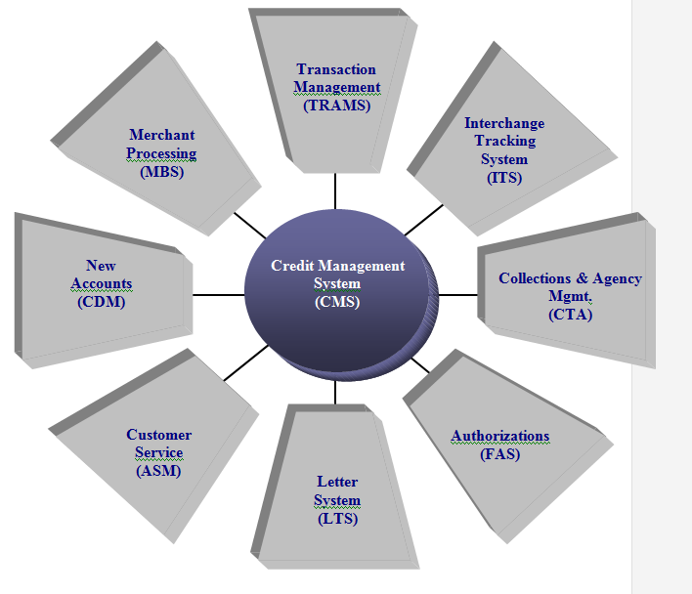

1. **Credit Decision Management (CDM)**

CDM enables businesses to design, input, process and track credit and debit applications according to their specified criteria. It allows tracking and storing information like:

*Policies Fields Edits Credit Limit Assignments*

*Fraud Searches Validations Decline Reasons*

*Scoring Operator Controls*

1. **Account Services Management (ASM) System**

ASM is a front-end module that enables Customer Service Representatives to handle the customer requests that are received in the organizations call centers. This module enables a representative to access customer account information and perform the necessary actions in order to service the customer request.

1. **Credit Management System (CMS)**

CMS is the core of Vision*PLUS* and provides a powerful, accounts receivable credit management system. This is where the real time account maintenance takes place. Activities like transaction posting, statementing, payment processing etc all take place in this module.

1. **Financial Authorization System (FAS)**

FAS is the module which takes care of providing authorizations for all incoming transactions. When a cardholder swipes his card, the card details along with the transaction amount are sent to the bank for verification and authorization. This activity of authorizing transactions is performed by the FAS module in VisionPLUS. It interfaces with the MasterCard and Visa authorization networks as well as supports private label authorization requests

1. **Interchange Tracking System (ITS)**

When a customer disputes a transaction, then there are a certain set of processing activities that have to take place between the various parties involved, in order to settle the dispute. ITS is the module in Vision*PLUS* that is used for these activities. ITS streamlines the processing of MasterCard, Visa, and Europay exception items and provides complete tracking capabilities for all items in process and automatically generates the support documentation required by MasterCard, Visa, and Europay

It interfaces with the TRAMS and CMS modules.

1. **Merchant Bankcard System (MBS)**

MBS is a stand-alone system that fully supports both bankcard and retail store merchants. MBS has the following features:

* Offers Merchant and store processing
* Provides the processor the ability to charge each merchant efficiently for services rendered
* Supports the posting, settlement and reporting of all monetary activity posted for each merchant.

1. **Transaction Management System (TRAMS)**

A customer can use his card at different places like ATMs, Retail Stores, etc and hence incoming transactions into VisionPLUS can be different sources. Generally, the format in which the data arrives from the different sources is different depending on the systems being used there. TRAMS is the transaction collection, processing and routing module in VisionPLUS that processes these transactions and converts their format into the format of the destinations (CMS module, VISA/MC networks etc) that these transactions have to be sent to.

1. **Letter System (LTS)**

At various points of time, several letters have to be sent to the customers. These could be application accepted/rejected letters, statement letters, new promotional offers letter etc. LTS is the module that is designed to generate letters through the use of online screens and batch processing. LTS also interfaces with the other modules and allows to request letters.

1. **Collections, Tracking and Analysis (CTA System)**

When an account becomes delinquent, then it needs to be sent to the collectors for them to follow up with the customer. The tracking and handling of delinquent accounts by collectors is facilitated in VisionPLUS by the CTA module. It allows management to decide what accounts are to be collected, in what order, how they are collected based on classes and accounts defined according to the organization’s risk standards.

This system provides real-time account information that collectors need to work on accounts efficiently.

1. **Security Sub System (SS)**

SS is a comprehensive Online Security System that interfaces between all Paysys Products. It also is the central location for Paysys common routines.

**Mapping of VisionPLUS modules with the Credit Product Lifecycle Phases**

***VisionPLUS Modules***

***Phases in Credit Product Lifecycle***

CDM Credit Initiation

ASM Account Maintenance (Customer Service)

CMS Account Maintenance (Financial Processing)

FAS Account Maintenance (Authorizations)

ITS Account Maintenance (Discount processing, Chargebacks)

MBS Account Maintenance (Merchant Processing)

TRAMS Account Maintenance (Transaction Routing)

LTS Credit Initiation

Account Maintenance

Collections

CTA Collections

Write Offs

SSC Credit Initiation

Account Maintenance

Collections

Write Offs

### Practical Example of use of Vision*PLUS* modules

You are redesigning your kitchen and you discover that you do not have readily available cash to use. You decide to apply for a GE credit card as this offers the best available terms and conditions. You fill out the credit card application and mail it to GE. GE uses Vision*PLUS* for its credit card handling process.

Upon receipt of your application the following actions take place in Vision*PLUS*.

* The **CDM** module verifies the application information, scores your credit worthiness and approves your application setting a Rs. 15,000 credit limit. CDM then passes the information to the CMS module for account setup.
* **CMS** establishes your account record, assigns account processing parameters, such as interest free period, billing cycle, late fees and overlimit criteria and issues your credit card.
* The **LTS** prints a letter to inform you that your application has been approved.

The following week, you receive your new GE credit card. You are now ready to complete the redesigning job by purchasing all new kitchen appliances. Once the purchases are made, the sales clerk at the store seeks an authorization for the purchases by swiping your new card through the POS (Point of Sale) machine. Your authorization request flows through the Vision*PLUS* modules as follows:

* **FAS** receives the authorization request from the POS machine.
* **FAS** reads the account information stored in CMS to determine if your authorization request should be approved. CMS checks criteria such as your available credit, account status, and other parameters.
* Using the information provided by CMS, FAS approves the transaction and sends the authorization code back to the POS machine.
* **LTS** sends a letter acknowledging your first card usage and welcoming you to the GE card user family.

Overnight CMS processes your sales transactions and your purchases are posted to your CMS account.

At the end of the month, you will receive your first billing statement showing all the purchases made to your new account. You review your statement and realize that your remaining available credit is only Rs. 1000, which is not enough to purchase some more kitchen furniture that you had planned for earlier.

You call GE’s customer service center, to request an increase in your credit limit. The customer service representative at the GE call center uses **ASM** to assist you. The following steps occur:

* The representative enters the request needed to process the credit line increase.
* ASM forwards the request to the Risk Management group for review.
* The representative schedules a follow up call for the next day to inform you of the decision.

The next day you receive a conformation that your credit limit has been increased by Rs. 5000. You can now purchase the furniture that you wanted and complete your remodeling project.

After two months, you receive a call from a GE representative informing you that you have failed to make a payment on the last bill. In Vision*PLUS*, the following has occurred:

* When the payment was not received, CMS flagged your account and sent it to collections.
* **CTA** prioritized your account and assigned it to a collector for follow up.

You thank the GE representative for the timely intimation and immediately write out a cheque to clear the outstanding balance.

The following diagram indicates the flow of information between the different modules of Vision*PLUS*.

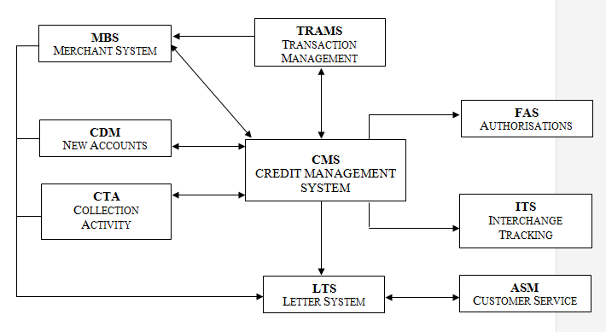

# How does GE use Vision*PLUS* and Satyam’s role?

## *GE’s Use of VisionPLUS*

GE provides consumer credit services to its clients across the world through GE Consumer Finance (GECF), earlier known as GE Capital. GECF uses Vision*PLUS* as a platform to deal with two kinds of credit products, namely:

* Sales Financing and
* Plastic Cards

***Sales Financing***

GECF supports sales financing in terms of offering a wide range of financial products to its customers. The company is a leader in most products including personal loans with specific loans for education, travel and healthcare, auto loans and leases, mortgages, debt consolidation and home equity loans and credit insurance. Vision*PLUS* supports most of the loan financing given to the customers. However, in mortgages and secured loans, the product needs to be tailored to suit the complications involved with regards to the interest rate calculation, value of collateral, etc.

***Plastic Cards***

GE has its presence in the credit card industry as well. The plastic cards that GE deals in can be broadly classified into 2 types, viz.,

* *Private Label Cards*: GECF supports several private labels cards in various countries. At present, in Mexico, GECF caters only to the Private Label Card segment.
* *Bankcards*: GECF incorporates its presence in this market by tying up with banks that provide the platform to introduce its service to the local customers. For e.g., in 1998, two joint ventures between State Bank of India and GE Capital were established to market, issue and service payment cards under the brand SBI Cards. GE therefore collaborates with banks and uses them as a channel to market its credit cards.

Vision*PLUS* majorly caters to the sales financing as well as the credit card industry. However, a large part of the activities are channeled towards servicing the credit card industry.

The following table indicates the work that GECF is doing in various locations across the world (that is supported on Vision*PLUS*), and the version and modules of Vision*PLUS* being used by it in these locations:

|  |  |  |
| --- | --- | --- |
| **Location** | **GECF’s Business supported on Vision*PLUS*** | **Vision*PLUS* Version and Modules** |
| Japan | GE has a bank here and plays the role of both the Issuing bank* and the Acquiring bank*. It has a tie up with the Sumitomo Bank, one of the 6 national banks in Japan.  GE provides the following products here:   1. Credit Cards 2. Sales Financing 3. Private Label/Retailer Cards   GE currently has about 20,000 credit card accounts and this number is likely to increase to 1,50,000 by the first quarter of next year. | *Version:* **8.07**  *Modules Used:*  CMS, FAS, CTA, TRAMS, LTS, SSC, MBS   * **,** ITS, ASM |
| Mexico | GE is primarily into Private Label Cards in Mexico. It has tie ups with 8-9 retailers and serves a customer base of over 3,00,000.  It is also entering the credit card segment very shortly by tying up with VISA. | *Version:* **8.12**  *Modules Used:*  TRAMS, CMS, FAS, CTA, ASM, LTS, MBS, SSC |
| Australia | GE offers the following types of credit products here:   1. Sales Financing for *BuyersEgde* 2. Private Label Credit Cards (PLCC) for *Coles Myer Ltd. (CML)* 3. Co Branded Credit Cards with *Select, Shell and OneLink* (through MasterCard). GE plays the role of an Issuing agency.   The total card base being supported at present is 3.4 Million which includes the MasterCard holders as well as PLCC holders. This number is expected to increase to 6 Million by the first quarter of 2004. | *Version:* **2.56**  *Modules Used:*  ITS, TRAMS, CMS, FAS, CTA, ASM, LTS, SSC. |
| Hungary | GE offers Debit Cards and Credit Cards here in collaboration with Budapest Bank, Hungary.  Most of the cards offered are issues through Visa. | *Version:* **2.56**  *Modules Used:*  ITS, TRAMS, CMS, FAS, ASM, CDM, SSC |
| Czech Republic | GE offers the following products on Europay MasterCard through GE Capital Bank, Czech:   1. Credit Cards 2. Debit Cards   GE plays the role of both the Issuer and the Acquirer for the above products. As of today, it has a total account base of 3000 in Credit Cards and 5,15,000 in Debit Cards. | *Version:* **2.56**  *Modules Used:*  ITS, TRAMS, CMS, FAS, CTA, ASM, LTS, SSC, MBS |
| India- SBI | GE offers Visa credit cards in India through SBI. The card base at present is approximately 21,00,000.  GE plays the role of an issuing agency. | *Version:* **2.56**  *Modules Used:*  ITS, TRAMS, CMS, FAS, CTA, ASM, CDM, LTS, SSC |
| U.K. | GE offers a unique product called the ‘Dual Card’, which combines the features of a PLCC and a Bankcard. At present this is being done only for the departmental store *Harrods* through Europay Mastercard. The total card base here is 70,000.  GE has a bank here called the GECF Bank, that plays the role of an Issuer. | *Version*: **8.0**  *Modules Used:*  ITS, TRAMS, CMS, FAS, CTA, ASM, LTS, SSC |

## *Satyam’s Role in GE’s use of VisionPLUS*

Implementation, Development, Transition, Maintenance & Support including HelpDesk, and Upgrades are the various phases involved in the Vision*PLUS* product lifecycle. Satyam has been primarily involved in implementation and maintenance activities for GECF across various sites.

***Implementation***

Satyam handles non-critical implementation activities for its client, GE. It helps in implementation of the product in three dimensions:

* *Basic Implementation:* Satyam provides resources on a temporary basis to assist in implementation of the product.
* *Customization:* Satyam handles non-critical and non-core customizations of the product.
* *Building Interfaces:* Satyam undertakes and manages simple and easy to understand non-critical interface development for Vision*PLUS*.

*Maintenance*

Satyam’s expertise in Vision*PLUS* is to primarily provide Maintenance/Support of the existing implementations in the following ways:

* *Production Environment Management:* This involves maintenance activities with regards to the day-to-day activities/operations of the client. Support is provided through:
  + Batch Abend Resolution
  + Batch Job Monitoring
  + Bug fixing
  + Capacity planning
  + Compliance
  + Migration support in terms of functionality (gap analysis of the existing structure and new structure) and data (mapping of the old data structure to the new one using common structure programs)
  + Version upgrades are also supported by Satyam. This includes conversion and customization support only.
* *Enhancements:* This involves meeting the customer requirements in light of the dynamic business environment. Satyam provides product enhancements according to the customer specifications, thereby meeting the business demands.
* *Development Environment Management/Development Region Support:* This involves:
  + Development batch support/monitoring

# Satyam’s Vision*PLUS* organization structure

Satyam has been involved with GECF in Vision*PLUS* for the last 6 years. Today, the Vision*PLUS* team at Satyam has about 140 people working on close to 45 projects. The total revenue generated by the Vision*PLUS* team at Satyam constitutes about 6% of the total revenue of GDC’s total revenue.

The following is the team structure for Vision*PLUS* at Satyam.

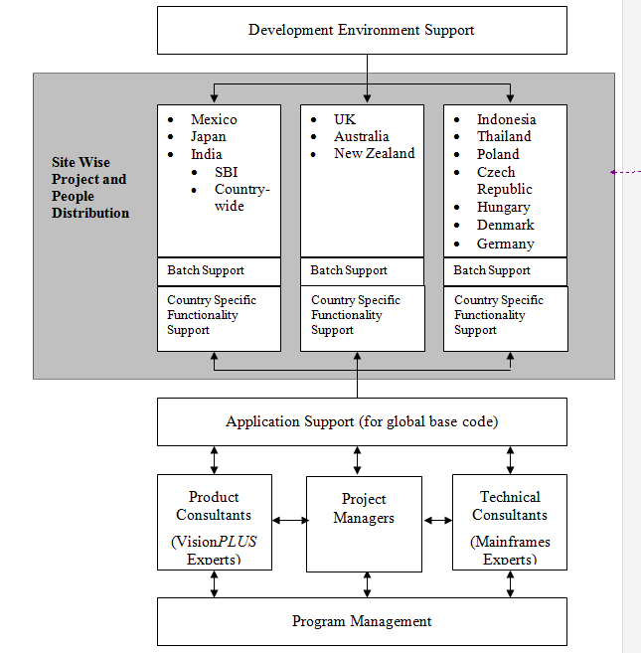

The Vision*PLUS* team structure at Satyam follows the concept of using dedicated resources for different location groups (Vision*PLUS* implementations in different GE businesses across the world have been grouped together in 3 groups to cater to the site specific customizations and interfaces as best as possible). Each location group has a dedicated Project Manager for all projects being done for GE in their respective groups.

However, there is a common pool of people for teams like ‘Development Environment Support’ and ‘Application Support’, who will be available to work on projects across all location groups, as the work involved in these teams is common across all locations.

Apart from this there are teams like ‘Product Consultants’ and ‘Technical Consultants’, which are the expert groups in the Vision*PLUS* product and Mainframes technology respectively.

* ***Development Environment Support*:** This team as mentioned earlier is primarily into providing Test Batch support for all projects across all locations.
* ***Site Wise Project and People Distribution***: Each location group comprises of a Project Manager and a team of dedicated resources that provides Batch Support and Country Specific Functionality Support. All projects under each of the location groups are served by their respective dedicated teams.
* ***Application Support*:** There is a common pool of people similar to the Development Environment Support team that provides application support for projects across any of the GE business locations. The scope of this team primarily involves working on changes to the base code of Vision*PLUS*, which is constant across all GE locations.
* ***Product Consultants*:** This team consists of Vision*PLUS* product experts. They are primarily involved in Analysis, Estimates and Designs for proposals and projects, Knowledge Management and Escalation Management for Vision*PLUS*.
* ***Technical Consultants*:** This team consists of Mainframes technology experts. They are involved in the feasibility analysis and implementation of processes where automated tools can be used, Knowledge Management for Mainframes and all other Technology Initiatives.
* ***Project Managers*:** Responsible for the delivery of all projects within their respective location groups. All team members working on any project report to the respective Project Managers. They also handle all project related escalations.
* ***Program Managers*:** Responsible for the overall Vision*PLUS* team at Satyam GEGDC. They are responsible for the top line and bottom line of the individual projects and the overall Vision*PLUS* account. All Project Managers, Technical Consultants and Product Consultants report to the Program Management team.

## *Career Path for Technical Analysts*

The following diagram depicts the career path along with the expected duration in the individual levels, for a Technical Analyst in the VisionPLUS team. The point of entry for the Associate will depend on the knowledge and level of experience that he/she possesses while joining the team.

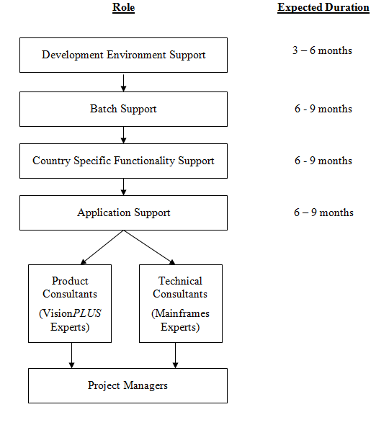

# Objective Of This Document

Level 1 gave the user an overview of Consumer Credit, the various stages involved in the lifecycle of any credit product and an introduction to the main modules in Vision*PLUS*. The objective of Level 2 is to provide the user with greater details on handling of a typical card transaction using Vision*PLUS*.

It has been structured so as to give the user an in-depth understanding of the complete flow of any card transaction and how the various modules of Vision*PLUS* interact with each other to facilitate the processing of the transaction.

The first part of the document provides a business overview of the Credit Card transaction process and the key players involved, while the second part comprises of how the transaction is handled by Vision*PLUS* using its various modules.

# Overview Of The Credit Card Process

## Introduction

### What are Credit Cards?

Credit cards are a form of revolving consumer credit that has a specific amount that can be borrowed against, in part or in full. As the outstanding balance is paid, the available credit line is restored for use once again. Credit cards typically offer a variety of other services as well, such as cash advances and convenience checks.

Credit Cards can be issued either by banks or other non-banking financial entities and are generally associated with the Visa or MasterCard organizations.

### Types of Credit Cards

There are primarily 2 types of Credit Cards:

1. ***General Purpose Cards***

General-purpose credit cards can be used at any merchant accepting MasterCard or Visa credit cards.

1. ***Proprietary/Private label credit cards/Limited purpose cards***

Proprietary or limited purpose or private label cards are associated with the retailer issuing the card and can be used only in that retailer’s stores.

## Credit Card Transaction Process

### Key Players

In any Credit Card transaction, there are a number of players involved from the time a purchase is made, till the time the bill is settled. The following are the key players involved in any card transaction:

1. ***Customer:*** The user of the credit card.
2. ***Issuing Bank:*** The Issuing Bank maintains the customer relationship. It solicits, screens and issues the card to the approved consumer. It is responsible for billing and collecting payments for all transactions made on the credit card by the customer*.*

It also receives the transaction details from the Acquiring Bank and makes the necessary authorizations for completing the transaction. It is also responsible for making the settlement to the Acquiring Bank for all transactions carried out by its cardholders.

1. ***Merchant:*** These are the retail stores, restaurants, airlines, mail order companies, petrol pumps, travel agencies etc where payments can be made using credit cards*.*
2. ***Acquiring Bank:*** The Acquiring Bank maintains the merchant relationship. It solicits, screens and accepts merchants into the program. It provides support services for the merchant like accepting the credit card transaction chargeslips from the merchants and crediting their accounts with the required payments*.*

The Acquiring Bank installs terminals at the Merchant site, through which card and transaction details for each transaction can be received by it and in turn passed to the Issuer for validation and approval.

The Issuing Bank and the Acquiring Bank can be the same in many instances.

1. ***Visa / MasterCard Associations:*** These are the associations that facilitate the **transaction processing and settlements between Issuers and Acquirers** across the world*.*

When credit cards were first introduced, banks had agreements with certain merchants to accept the credit purchases of card holders. When a purchase was made, the cardholder presented the card to the merchant, who would copy the information on the card on to the sales slip and send it to his bank. The purchase was credited to the merchant’s account in the bank less the discount rate. However, a major drawback was that cardholders could shop in their own geographic area and only at merchants that their banks were able to sign up. To overcome this drawback, **Bank of America** began forming licensing agreements with few banks **outside California** to issue the **BankAmericard, which in 1976 changed its name to Visa.** In 1966, certain other **banks got together in Buffalo**, New York, to form their own network, called the **Interbank Card Association – which is now known as MasterCard International.**

As the Visa and MasterCard organizations gained prominence, most banks no longer tried to enter the credit card field alone, but rather joined one of the two that were already in existence. The banks agreed to issue cards displaying both the individual bank name and a symbol signifying that the bank was part of a larger network of banks agreeing to interchange transactions. This interchange feature made the card more attractive to merchants because of the greater pool of current and potential cardholders.

By the early 1980’s, the Visa and MasterCard systems had expanded throughout the world and today they dominate the bank credit card industry in a number of countries. These associations perform the authorizations, clearing and settlement that allow a bank credit card to be used at any merchant that is a member of the association.

MasterCard International and Visa International are owned by member banks and governed by separate boards of directors. Both MasterCard and Visa own and operate international processing systems that provide capabilities to authorize purchases and settle merchant and cardholder transactions. Visa and MasterCard serve this function through networks and automation, bringing together the collective resources of banks and other financial institutions.

Banks can become members of both Visa and MasterCard.

### Credit Card Transaction Cycle

The following diagram depicts a typical credit card process cycle from the time a consumer applies for a credit card, till the time the bill is settled for the purchases made.

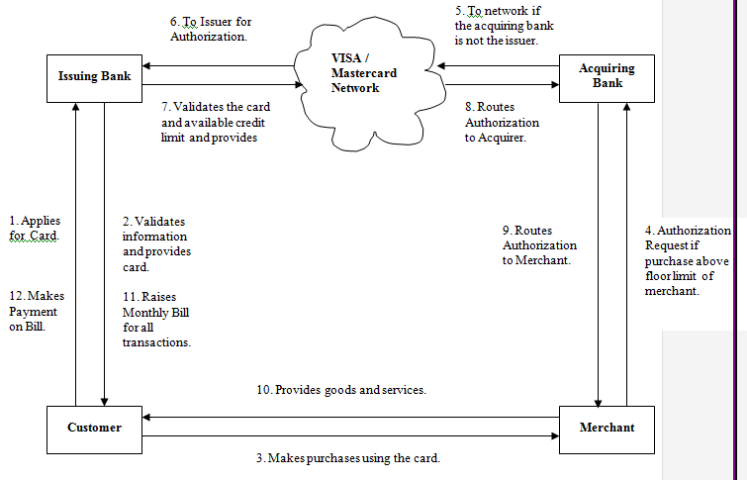

The process starts with the consumer applying for the credit card to the Issuing Bank. The Issuing bank evaluates the application and after the required verifications, issues a Visa / Mastercard credit card to him with a specified credit limit. The card can then be used by the customer in any merchant store which accepts Visa cards / MasterCards.

When the customer makes a purchase in a store using his/her credit card, the merchant system refers the card and transaction details to its Acquiring bank, for card verification and authorization of the transaction. This is done for all transactions above the merchant’s floor limit, which is generally Rs. 100 - 500.

The Acquiring bank checks for the Issuer of the credit card on which the transaction has been made. In case the Issuer is some other bank, it routes the transaction to the Visa or the MasterCard network depending on which network the card belongs to else the authorization process if carried out by the Acquirer itself.

The Visa/MasterCard network then evaluates the card details and routes the card and transaction details to the Issuer bank.

The Issuer bank in turn validates the card information received from the network with the details it has stored in its systems. Having validated the card, the Issuer then approves/declines the transaction based on the transaction value and the available credit limit.

This authorization information is routed back to the merchant via the Visa/MasterCard network and the Acquiring bank. The merchant then provides the goods and services to the customer or declines the transaction if the authorization was positive or negative, respectively.

### How do different players make money?

There are different sources of income for the individual players in any card transaction that takes place. The following are some of the income sources in a card transaction:

1. ***Interchange Fees:*** The Acquirer pays the Issuer a small percentage (1-1.6%) of the rupee transaction amount. This fee reimburses the Issuer for the cost of processing the transaction and the free period between settlement and payment. It contributes approximately 20% of the bank’s credit card revenue.

The Acquirer pays the interchange fee to the issuer through the Visa / MasterCard Settlement System. Interchange fees are set by the National Associations. There is one set for VISA and another for MasterCard transactions. The fee depends on the type of authorization, Merchant type, Card type etc. The interchange fee is called Merit for MasterCard transactions and EIRF (Electronic Interchange Reimbursement fee) for Visa.

1. ***Merchant Discount:*** This is the fee the Acquirer charges the Merchant in return for processing the transaction (handling cardholder purchases) and the cost of the Interchange fee. The Merchant Discount is generally about (1.7 – 4%) of the transaction amount and depends on the Nature of the Card, Merchant Sales, and the realization period for the chargeslips.
2. ***Interest Charge:*** This is the charge that the Issuer levies on the Cardholder on the unpaid monthly balances. This is approximately 20-36% per annum and is also called the ‘Annual Percentage Rate (APR)’*.* This is the largest source of income for the Issuer and contributes to about 70-75% of the total income.
3. ***Annual Fees:*** This is the fee the cardholder pays to the issuer for the right to carry and use the bank credit card. This accounts for approximately 5% of credit card revenue for the Issuer*.*
4. ***Service Fees:*** This is the fees that the Visa and MasterCard associations charge the member banks for providing the clearing and settlement networks and undertaking other services like arbitration, stand-in authorizations etc.

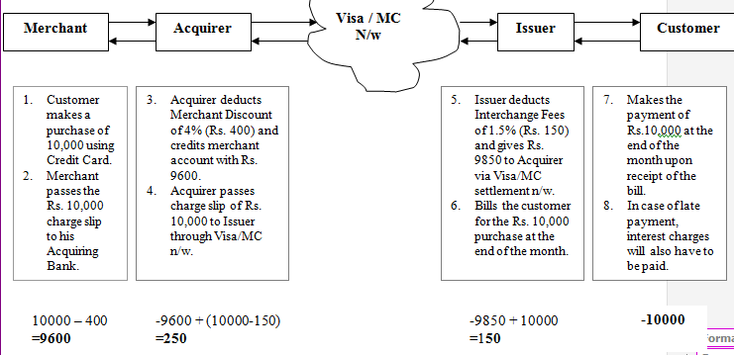

### Details of Players’ functions and economics

###### 1. Issuer Bank

Advantages to Issuer Bank

* Credit cards give banks the opportunity to attract customers who do not live nearby. With a credit card, the bank’s location is irrelevant. Then can thus increase their market areas.
* Banks can use this remote feature to expand their market areas.
* Credit can be extended via mail and phone.
* New cardholders make excellent prospects for cross-selling additional bank products.
* Banks’ outstanding loans grow quickly as a result of credit card programs.

Functions / Business Roles

* Administration (management of business).
* Marketing (cardholder solicitation and activation programs).
* Credit evaluation.
* Application processing.
* Credit processing (credit decision and set up of new accounts).
* Card issuance (embossing, encoding, issuing plastic cards).
* Incoming interchange (processing incoming cardholder transactions and cardholder chargebacks).
* Cardholder billing (preparing and mailing cardholder remittances).
* Payment processing (processing, posting cardholder remittances)
* Customer service (handling cardholder inquiries, complaints).
* Overlimit (monitoring, resolving overlimit account situations)
* Collections (collecting outstanding dues from delinquent accounts)
* Fraud control (handling reports of lost or stolen cards and reviewing activity on blocked accounts)
* Cardholder authorization (updating cardholder Masterfile with Authorization requests, and liaison with the National Associations, which process the majority of Authorization requests).

Revenue side of Issuer economics

* Interest income
* Interchange income
* Annual membership fees
* Other fees and income – represents charges and revenue generated by activities like Cash Advance Fees, Balance Transfer Fees, Credit Insurance, Revenue from selling Merchandise, Exception Processing Fees, etc.

Expenses

* Cost of Funds (interest paid to get funds)
* Loss / Bad Debts
* Servicing Expenses (‘front end’)
* Processing Expenses (‘back end’)
* Marketing Expenses (for acquiring new accounts)
* Collection Expenses

***2. Issuer Processor***

There are several alternatives that banks (Issuers) can adopt.

* Large banks, may opt for an ‘in-house’ unit for all the services.
* Regional associations formed by a consortium of geographically linked banks is another alternative.
* Increasingly, many banks are choosing outsourcing to provide front end and / back end support.

Thus some of the functions of the Issuer Processor could include:

* Marketing (cardholder solicitation)
* Credit evaluation
* Card issuance (embossing, encoding, issuing plastic cards)
* Cardholder billing / Statementing (preparing, mailing cardholder bills)
* Data processing
* Customer service (handling cardholder inquiries, complaints)
* Collections (collecting outstanding dues from delinquent accounts)

***3. Acquirer Bank***

Advantages

* Merchants pay discounts to banks for handling cardholders’ purchases.
* In addition to discount income, merchants bring additional deposits to banks. The merchant sales draft is treated as a deposit item, thus becoming new sources of funds for making loans.

Functions / Business Roles

* Center administration (overall administration and control of merchant relationships)
* Proof and capture (processing, reconciling all credit transactions made at the merchant outlets and deposited to the merchant account)
* Outgoing interchange (processing outgoing sales drafts and cash disbursements upon completion proof and capture, handling merchant chargebacks, and data retrieval requests)
* Risk management (processing new merchant applications and assuring the credit worthiness of new and existing merchants, monitoring merchants for suspected fraudulent activity)
* Merchant sales (soliciting and signing up new merchants and providing both in house and filed support to the merchant base.)
* Merchant authorization (providing timely response to electronic and voice authorization requests from member merchants)

Revenue side of Acquirer economics

* Merchant discount
* Earnings on deposits – net interest earned on merchant checking account deposits
* Other income – revenue generated from such items as the sale/rental of point-of-sale (POS) terminals and imprinters, monthly fees and application fees.

Expenses

* Processing Expenses
* Sales and Marketing Expenses
* Outgoing Interchange
* Credit and Fraud Losses

***4. Acquirer Bank***

Some of the Acquirer activities can be out sourced. They include:

* Data Processing
* Credit evaluation
* Voice Authorizations

***5. Credit Card Holder***

* Convenience of purchasing goods and services.
* Wide acceptance by many merchant establishments.
* Freedom to use credit without having to go to the bank to apply for a loan that would then have to be repaid with a monthly payment.
* Amount of credit used can be paid in full by the payment due date or can be repaid in flexible monthly installments.
* Payment on purchases can be delayed for about one month.
* Offer a comparatively safe means of conducting transactions. The potential loss is much lesser than if currency is lost or stolen.
* Facilitate internet / mail order shopping.
* Credit cards facilitate record keeping.

***6. Merchants***

* Credit cards make it easier for consumers to purchase goods, thus boosting merchants’ sales.
* Consumers are more likely to make larger purchases when credit is used instead of cash.
* MasterCard or Visa brand identification extending to merchants increases the likelihood that customers will seek out and patronize merchants that accept the card.
* Sales transactions are fairly easy to validate.
* The merchant has none of the risks inherent in extending credit or accepting checks.
* No necessity for the merchant to contact a purchaser directly in an attempt to collect money. By following the proper procedure, the sale is validated, and the merchant receives payment from its bank.

***7. VISA / MasterCard Associations***

##### *Business Roles/ Functions*

* Licensing
* Setting operating regulations
* Standardizing interchange, clearing and settlement procedures
* Perform Authorizations for Merchant members
* Processing cardholder and merchant transactions
* Provide members with marketing, advertising support
* Assist in security & fraud control

VISA/ Mastercard

* The systems for authorizing transactions are INAS for MasterCard and Base I for VISA.
* The systems for settling Merchant and Cardholder transactions are INET for MasterCard and Base II for VISA
* The bulk data transfer systems that process cardholder and merchant transactions (payment billing), including currency conversion are BankNet for MasterCard and VisaNet for Visa International

***Revenue***

* Fees charged to member banks based largely on bank card volumes
* Assessments

# Use Of Vision*PLUS* For The Credit Card Transaction Process

This section talks at a conceptual level about how Vision*PLUS* and its various modules are used for handling the various phases in the credit card transaction process. The section covers the entire credit card procedure end to end, in terms of how the various modules of Vision*PLUS* deal with the respective phases and interact with each other.

For ease of understanding, the entire process has been broken down into the following major phases:

* Product Planning
* Application Processing
* Account Setup
* Issue Processing
* Authorizations
* Transaction Routing
* Transaction Posting
* Statement Processing
* Payment Processing
* Delinquency
* Collections
* ChargeOffs
* ChargeBack Processing
* Customer Service
* Customer Communication
* System Security
* Fraud Management

## Product Planning

This procedure involves business decisions taken by the organization in terms of which credit product it wants to offer and the target market it wants to cater to. Vision*PLUS* does not specifically have any module that aids an organization in planning the type of credit product it wants to provide. This is purely a business decision that needs to be taken by the organization’s management.

However, once the business decides the credit product that it wants to deal in, Vision*PLUS* serves as a tool that allows the organization to store valuable information about the credit product, its customers, customer details, transaction details etc. This data can be translated into input information when the organization plans for its future products in the same geography.

For e.g., the data can be used to draw out the past behavior of the customers and predict the future behavior as well based on the past trends, it can be used to find out the delinquent customers based on the payment history and the transaction details. The various modules in Vision*PLUS* hence serve as an MIS that allow the organization to take strategic decisions based on the existing customer base that it possesses.

## Application Processing

*Once the organization decides which credit product it wants to offer, application forms have to be designed and sent across to capture details of the customers who are interested in applying. This can be by direct mailers to a pre approved list of customers or by placing the applications at various stores, banks etc. Having received the completed applications, they are evaluated and scored and then either accepted or rejected for issuing cards. For applications that have been accepted, decisions regarding the credit limit to be made available have to be taken.*

The **Credit Decision Management (CDM)** module in Vision*PLUS* handles Application Processing. It aids in application design and application processing. There are a sequence of steps that are followed in CDM for tracking and processing applications:

##### Processing Applications using CDM

The following are the steps that are followed for processing applications forms in CDM:

* ***Application Design:*** CDM has the flexibility to design the format of the application forms that will be used to capture customer information. The format matches the sequence of the printed applications.
* ***Application Input:*** Having received filled up application forms, the information can be entered into CDM either manually into the Application Input Screens, or loading files from external systems.
* ***Application Edit:*** For forms received from external sources, the edit process needs to be performed in order to check for missing data. If missing data fields are found, the system places it in the operator’s queue for his action.
* ***Pre-validation Process:*** In this step, the application form is checked against the policy issues of the organization to determine if it meets the minimum requirements for credit.
* ***Cross Check Process:*** Here internal and external cross checks are made with the data on the application form to determine if the information matches.
* ***Application Scoring:*** Weights are assigned to the individual fields on the application form and total points accumulated by each form are calculated. Based on the cut off scores, the application is passed to the next stage or rejected.
* ***Data Verification Process***: There may be certain fields on the application that require the operator to call and verify with the applicant over the phone or letter.
* ***Credit Bureau Scoring:*** Credit Bureau information for each application is sought and once received, it is scored. Depending on this score, the application is either passed onto the next stage or declined.
* ***Combined Score:*** The application score and the bureau scores are used to generate a combined score for the application. Based on the cutoff, the application is either passed on or rejected.
* ***Final Judgement Process:*** The system applies any final criteria or policies on applications that have reached this stage to pass them or decline them.
* ***Setup:*** Approved applications can be set up as accounts in the CMS module. CDM interfaces with CMS in order to setup accounts. The following is the minimum information passed from CDM to CMS in-order to setup the account.

**CDM Field CMS file affected**

Customer Name Name and Address record (AMNA)

Organization Account Base Segment Record (AMBS)

Logo Account Base Segment Record (AMBS)

Account Number Account Base Segment Record (AMBS)

Billing Cycle Account Base Segment Record (AMBS)

State of Issuance Account Base Segment Record (AMBS)

Apart from the inherent risk that an application holds, the **source** from where the application has been picked up by the customer plays a vital role in deciding for/against an application. The ***source code* holds this information in a 19-digit field**. The source allows the organization to determine whether the application was filled out with a serious intention to purchase a credit product or not. It also enables the organization to determine the hit ratio that it has received in reaching out to the customers. This later on can be used in deciding whether that particular source has been beneficial in penetrating the market to its fullest. The organization can hence decide whether it would want to include it in its next marketing campaign

## Account Setup

Once an application has been approved and the Issuer has decided to provide the customer with a credit product, an account is created in the customer’s name that records the various transactions done on that particular card. All account related information is stored in the Credit Management System (CMS) module of VisionPLUS.

The following are the various keys created for the customer in order to identify the relationship maintained with him/her.

|  |  |  |
| --- | --- | --- |
| **Primary Key** | **Function** | **File in CMS** |
| Customer Number | This is the first record that is created for a new account. This contains the customer’s demographic information such as name, address, telephone number and place of employment. The customer number identifies the particular name/address record. | AMNA |
| Relationship Number | The relationship record contains the information about all accounts associated with a customer. The Relationship number is used to identify the customer as a portfolio of all the credit products held by him/her at any point of time.  For e.g., if the customer has a credit card as well as a home loan with the same organization, he/she will posses only one relationship number that identifies him/her across the entire portfolio. This allows the organization to take decisions with respect to credit limits and the type of products it might offer him in future and based on the customer’s behavior pattern. | AMRM |
| Account Number | Each product held by the customer is called an account (e.g. Gold Credit Card, Silver Credit Card, Home Loan, Personal Loan etc). An account number is used to identify the credit product held by the customer. In other words, it is the identification of an entity, which holds all the financial transactions of a customer for one particular credit product.  Information regarding the account is stored in the file called the *Base Segment*. | AMBS + AMPS  AMBS is the Base Segment |
| Card Number | For every credit card account, there can be multiple cards issued to the customer (generally in the case of Primary & Secondary cardholders for private cards or in the case of Corporate cards). A *Card Number* that is unique to each card is printed on the credit card. A Primary card is given to the cardholder who has the financial responsibility. The Secondary cards are given to the dependants of the primary cardholder.  **Information regarding each card is held in the respective** ***Embosser***files. **These *Embosser* files are attached to the single *Base Segment* file to which they belong**. Account / Card Number Details Every account / card number is a 16 digit number.   * **The first six digits are the BIN numbers provided by Visa / Mastercard** * Digits **7-9 are the logo number** i.e. they identify the product. * The **10th digit is a variable identifying whether it is an account number or a card number**. * Digits **11-15 are randomly generated by the system**. * The **16th digit is a Mod Check Number**. | AMED |

Given below is the diagrammatic representation of how the account structure looks for a Privately held credit card with a primary cardholder and two secondary cardholders:

**Private Card (One Primary Card Holder and 2 Secondary card holders)**

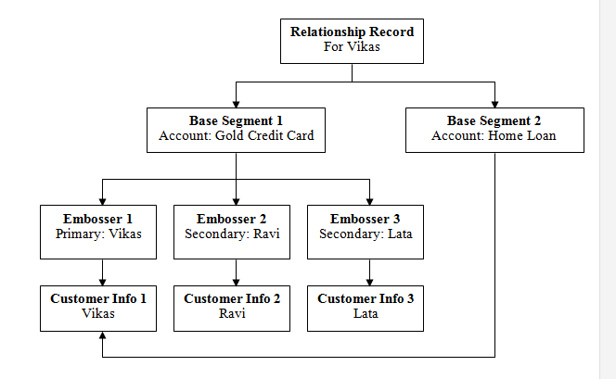

In the above example, Vikas is the Primary Cardholder. Ravi and Lata are Secondary Cardholders. The details of Vikas are held at a common place in order to be accessible to both the credit products held by him, viz., the credit card and the home loan.

This the relationship record further signifies that all the details of Vikas will be held in order to keep track of the various credit products the customer has in his portfolio.

## Issue Processing

Once the credit card account is created, the following 3 files are then created in the **CMS** module in order to store card specific information*.*

1. ***Embossing File*:** This is the information required for printing the plastic.
2. ***Card Mailer***: This is the information required for mailing the plastic.
3. ***Pin Mailer***: This is the information required for using the plastic.
4. **Embossing File*:*** This file contains the following information:

Front of the card

**Name to be Printed Member Since Expiry Date Card Number**

Back of the Card

***On the Magnetic Strip***

**Name Card Number Expiry Date Service Code**

**CVV1 / CVC1* (3 digit number)**

***Outside of the Magnetic Strip***

**CVV2 / CVC2 (3 digit number embossed on the signature panel)**

CVV1 (Card Verification Value 1) is used by the Issuing bank to check the authenticity of the card using which the transaction has been made. CVVI is a function of Card Number, Expiry Date and the Service Code. CVV2 is also a function of these three fields, however, it is a different number. It is mostly used for Voice Authorizations.

To capture and transmit information needed for the authorization of the card, **POS (Point of Sale) / EDC (Electronic Data Capture)** machines installed at the Merchant stores are used. POS machines transmit only the authorization information present on the Magnetic Strip while the EDC machines can be used for transmitting other information also. **EDC is a more sophisticated POS machine that allows the merchant to send additional data like transaction details as well**. However, in case the POS/EDC terminals are not working, then the merchant can read out the field CVV2 over the phone for authorization.

When a card is swiped on a merchant terminal, the following four fields are transmitted to the acquiring bank’s systems.

**Expiry Date Card Number Service Code CVVI**

*\*****CVV*** *is used in case of* ***VISA cards*** *and stands for* ***Card Verification Value****.*

***CVC*** *is used in case of* ***MasterCard*** *and stands for* ***Card Verification Code****.*

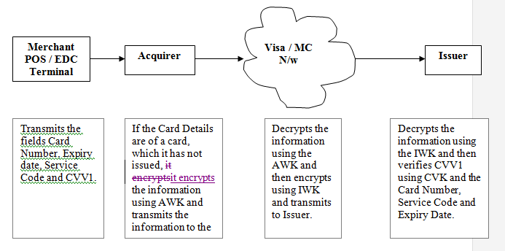

These fields are transmitted by the merchant terminal to the Acquiring Bank’s system, which in turn **encrypts using the Acquiring Working Key (AWK)** and then transmits it to the Visa/MasterCard Authorization network in case the Issuer of the card is some other bank.

The Visa/MasterCard network inturn **decrypts the information using the AWK, encrypts the information using the Issuer Working Key (IWK)** and then retransmits the information to the Issuing Bank. When the Issuer receives the information, it decrypts the information using the **IWK**.

The Issuer has a **standard Card Verification Key (CVK)**, which is used for the verification of the CVV1 values of all cards it issues. **The CVK is used in conjunction with the fields Expiry Date, Service Code and Card Number (received over the network) to generate the CVV1**. This is then compared with the CVV1 value received over the network. If a match is found, a positive authorization is made, else the authorization is declined.

1. **Card Mailer:** This file contains information like the Customer’s mailing address, phone number etc. that can be used to mail the card and the pin to him/her.
2. **PIN mailer:** This file contains the PIN that helps the customer activate the card and also use it later for **cash transactions at ATMs**.

The PIN that is sent to the customer in order to use his/her credit card is a function of the **card number, length of the PIN, card number length, expiry date, and a random key**.

**Card Activation**

Once the customer receives the card as well as the PIN, he/she can get is activated in the following ways:

* Call the Customer Service Representative who activates the card
* Take a cash advance on the card. This automatically activates the card since he needs the PIN to make a cash transaction and the PIN is sent to the cardholder in a separate mailer.

The customer can then carry out other transactions on his/her credit card.

## Authorizations

The process of verification of the authenticity of the card using the details received over the network when the card is swiped, and the credit limit of the card is called Authorization. In VisionPLUS, the module used for this is Financial Authorization System (FAS).

There are 2 types of Card usage possible:

1. *Cash Advances*: Authorizations done at **ATMs, and at Merchant Sites** when using Cash Access facility.
2. *Purchases*: Authorizations possible Via **EDC/POS terminals, over Voice networks, over the Internet and Manual Authorization** possible.

In case of VISA, the authorization network used is called Base 1 while the network used for MasterCard is called INAS. Incase of Private Label Credit Cards, local networks are used.

**Approval**

**ISO 8583** is the international standard used for transmitting data required for authorizations. **FAS can receive information only in ISO 8583 format**. If the incoming information from the merchant POS/EDC terminals is not in the ISO 8583 format, then a pre-processor is used by the Acquiring Bank to first convert the information into the ISO format for use by the FAS system.

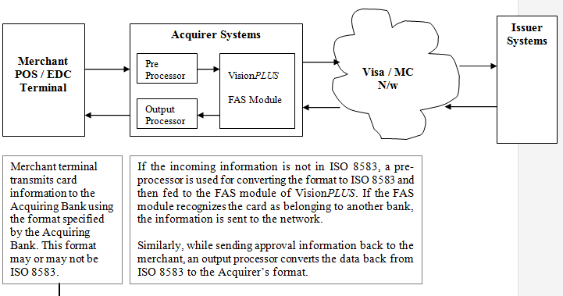

When card information is received by the Acquirer bank for authorization from the merchant, there are 2 scenarios possible.

1. ***Scenario 1***: The Acquirer’s FAS recognizes the card to belong to the Acquirer itself using the BIN information on the Card Number i.e. the Acquirer is the Issuer also.

In this case, the Acquirer’s FAS does basic validation like Card Number, Expiry Date, Status Check (not reported as a fraudulent or lost card), credit limit and velocity checks (number of transactions previously received from this card during that day). Having verified this information, it then checks for the CVV1 value and once validated, it sends an approval response back to the merchant.

1. ***Scenario 2***: The Acquirer’s FAS recognizes the card to belong to another bank i.e. the Acquirer is not the Issuer of the card.

In this case, the FAS transmits the encrypted card information to the Visa/MasterCard network, which in turn transmits it to the Issuing bank. The information is then processed by the Issuer’s FAS module as described above.

There are occasions when the Issuer’s systems are down and the Issuer cannot authorize any incoming requests from the network. There is a pre-specified duration within which the Issuer system has to respond to the request from the network. If no response is received within this duration i.e. the Issuer systems are down, the Visa/MasterCard systems undertake what is called the **‘Stand In Processing (STIP)’** i.e. they perform stand-in authorizations for the Issuer.

The stand in authorizations are performed on the basis on some pre-defined standard checks like cross checking the card number against the ‘Exception File’ (the exception file is a file of fraudulent/lost cards that the Issuer sends to the Visa/MasterCard network on a daily basis), checking for expiry date etc.

After the Issuer systems come back up, all the authorization advises are sent by the Stand in Processor to the Issuer.

##### **Post Approval**

Once the card validity has been established and approval response sent back, the system needs to validate whether the transaction amount is within the available the credit limit of the card at that point of time.

The available credit limit of a card at any point of time is called ‘**Open to Buy (OTB)**’. It is calculated as follows:

**Open to Buy = Total Credit Limit of Card + Overlimit % of Card –[Current Balance + Memo Debits – Memo Credits]**

***Current Balance*** is the total amount of the authorized transactions for which settlements have been made i.e. transaction chargeslips have been received by the Issuer from the Acquirer.

***Memo Debits*** are those total outstanding authorized transactions, which have not been settled yet i.e. the Issuing bank has not yet received the transaction chargeslips from the Acquirer.

***Memo Credits*** are those outstanding **reversals/chargebacks**, which have not yet been settled.

Whenever a transaction is approved after the validity of the card has been established and the transaction amount is verified to be lower than the OTB, FAS does the following:

1. Update the **Memo Debit / Memo Credit amount in the CMS module**.
2. Update the **Authorization Log file (in FAS itself)** with the details of the transaction.

The daily transactions are recorded in **FAS in the ‘Authorization Log’** till the end of the day. **At the end of the day, all transactions are moved to the CMS module to a file called AMOA.** This is because **all settlements are made in CMS**.

**After the settlements (transaction chargeslips) are received, matching of the chargeslips is done with the AMOA records** and after a match is found, the record is deleted from AMOA. The Memo Debit is reduced and the Current Balance is increased.

***Example***: Vikas has received a new credit card with a Total Credit Limit of Rs 10,000. He has not made any transactions on it. At this point of time his OTB is:

10000 (Total Credit Limit) + 1% (Overlimit %) - [0 (Current Balance) + 0 (Memo Debits) –0 (Memo Credits)] = 10,100

Now, Vikas makes a purchase of Rs 3,000 at a merchant store using his credit card. FAS updates Vikas’ account for the Memo Debit amount on his credit card to 3000, since the Acquirer has not yet made the settlement. After this, the OTB gets updated to:

10000 (Total Credit Limit) + 1% (Overlimit %) - [0 (Current Balance) + 3000 (Memo Debits) – 0 (Memo Credits)] = 7,100.

After 2 days, when the Acquirer presents the transaction chargeslip to the Issuer, the Memo Debit is reset to ‘0’ and the Current Balance is updated to ‘3000’. Hence the OTB remains the same:

10000 (Total Credit Limit) + 1% (Overlimit %) - [3000 (Current Balance) + 0 (Memo Debits) – 0 (Memo Credits)] = 7,100.

## Transaction Routing

Vision*PLUS* is a Dual Messaging System i.e. **the system/network that handles the Authorization requests does not support the settlement requests**. **The Settlement requests are sent via a different network. This network is called Base 2 for Visa and INET for MasterCard.**

Once an authorization for a transaction has been made, the merchant needs to send the transaction details to the Acquiring Bank in order to the **initiate ‘Settlement’**. Settlement is the process whereby the Acquiring Bank pays the merchant for the goods and services delivered by him to the customer. Merchants generally send all transactions to their Acquiring Bank’s system in batches, periodically (once a day or twice a week).

There can be several sources of transactions for the credit card transaction processing system. Transactions can originate from **retail merchant purchases, ATMs**, **internal fee generation transactions** etc. As such, the format in which these transactions are received by the system can vary according to the source from it was received.

Similarly, the destination of each transaction can vary. Some may have to be routed to different modules of the same system while others may have to be sent to different systems altogether. Each destination system may have its format for accepting and understanding information.

Hence there needs to be a module that helps understand the formats of the different systems from where transactions have originated, identify the destination systems and the route the transactions to the destination systems. This is taken care of by the module called **Transaction Management System (TRAMS)** in Vision*PLUS*.

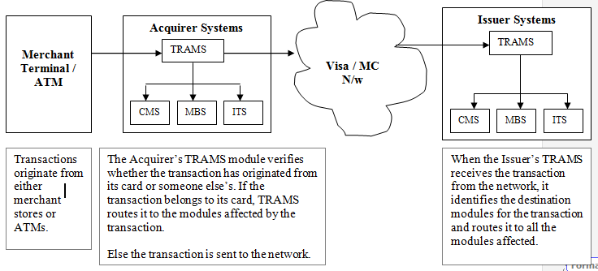

**Working of TRAMS**

There are 4 major steps involved in the working of this module. These are:

1. ***Input Processing:*** TRAMS uses a COBOL program called the Input FilePath to recognize the formats and accept the incoming transactions from the different sources. This program also helps in identifying the various destination points for the incoming transactions. Transactions can be the source systems to TRAMS at multiple points of time in a day.
2. ***Warehousing:*** TRAMS stores the transactions in a warehouse till the time it can send the transactions to the various destinations in their processing windows. The system can also warehouse all transactions received at various points of time during the day and release it all at one time at night. **Warehousing is done in** **AMWT file in CMS.**
3. ***Reject/Suspend:*** Transactions that have failed due to an error can be warehoused for later review and correction. Also, transactions that are correct but need review (transactions causing the account to be overlimit) can be suspended for later action.
4. ***Output Processing***: TRAMS uses a COBOL program called the Output FilePath to create output files for transmission of the transactions to the various destinations in the formats required by them. There can be upto **10 destinations for a transaction.**